MACHINE LEARNING

ASSIGNMENT 2

NAME: DURGAM NAGA DEERAJ REDDY

USN: 22BTRAD013

Q. Load a dataset with outliers values (Boston Housing Dataset)



CODE:

# DURGAM NAGA DEERAJ REDDY(22BTRAD013)

import pandas as pd

# Load the Boston Housing dataset

boston_housing = pd.read_csv('HousingData.csv')

Q. Use visualization or statistical methods to detect outliers

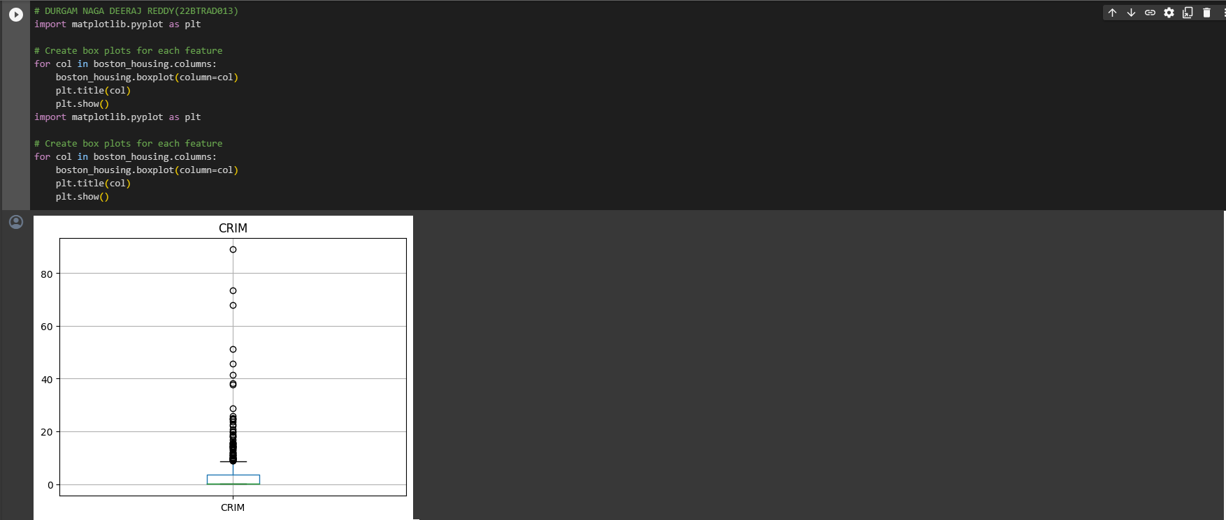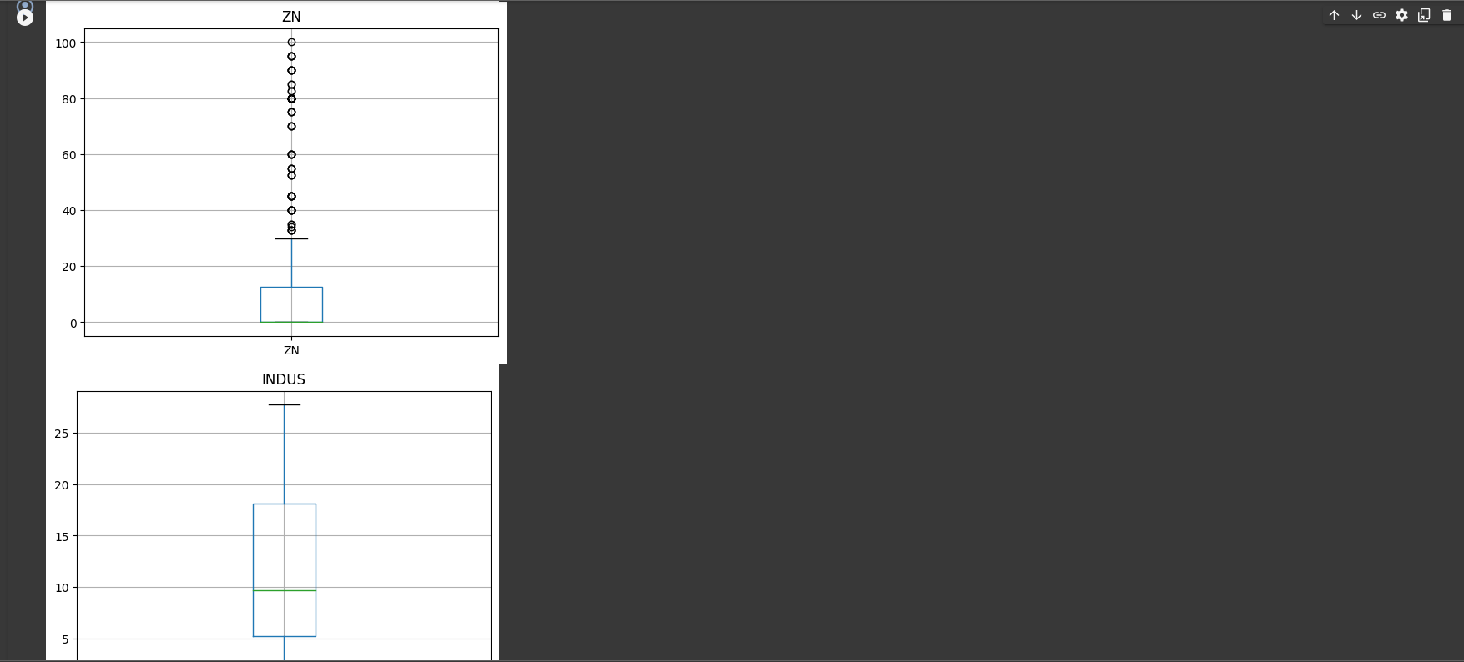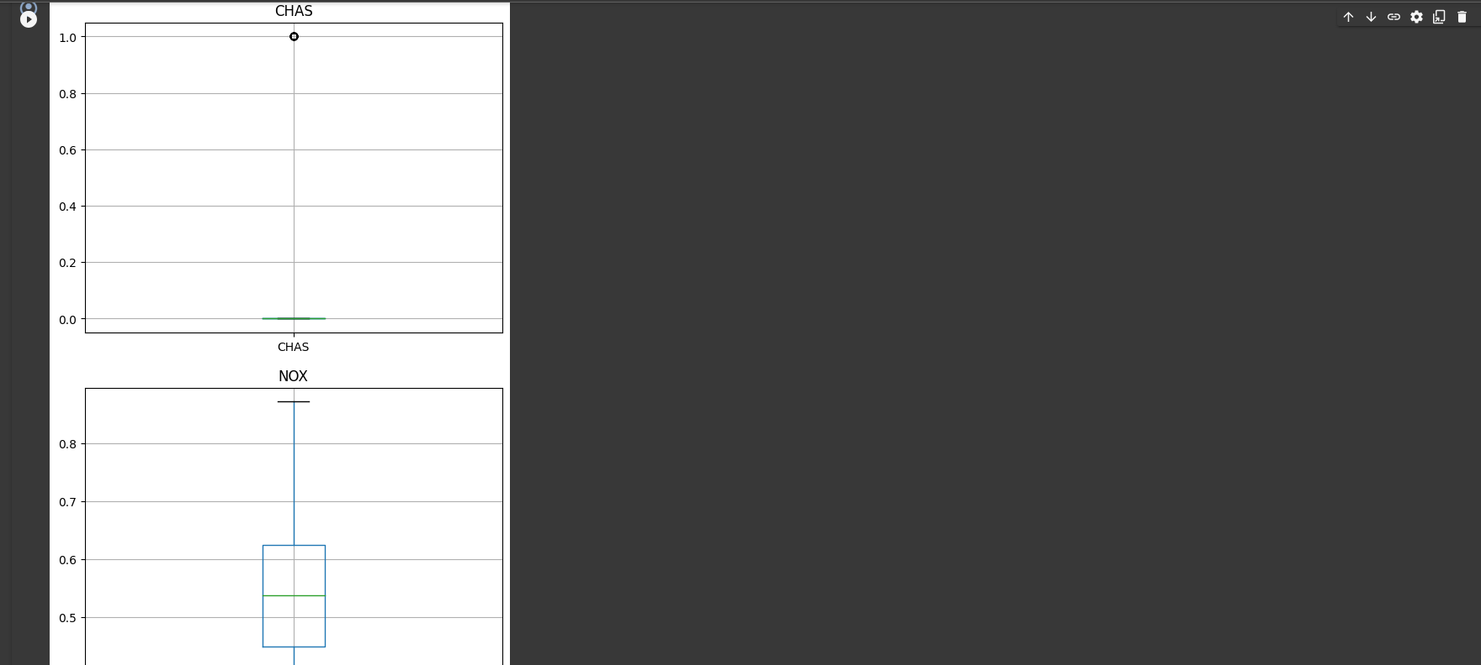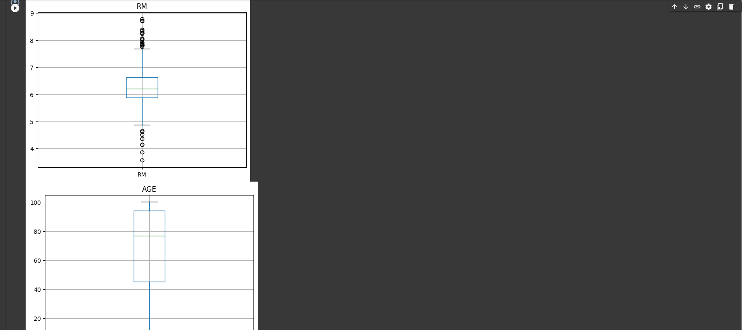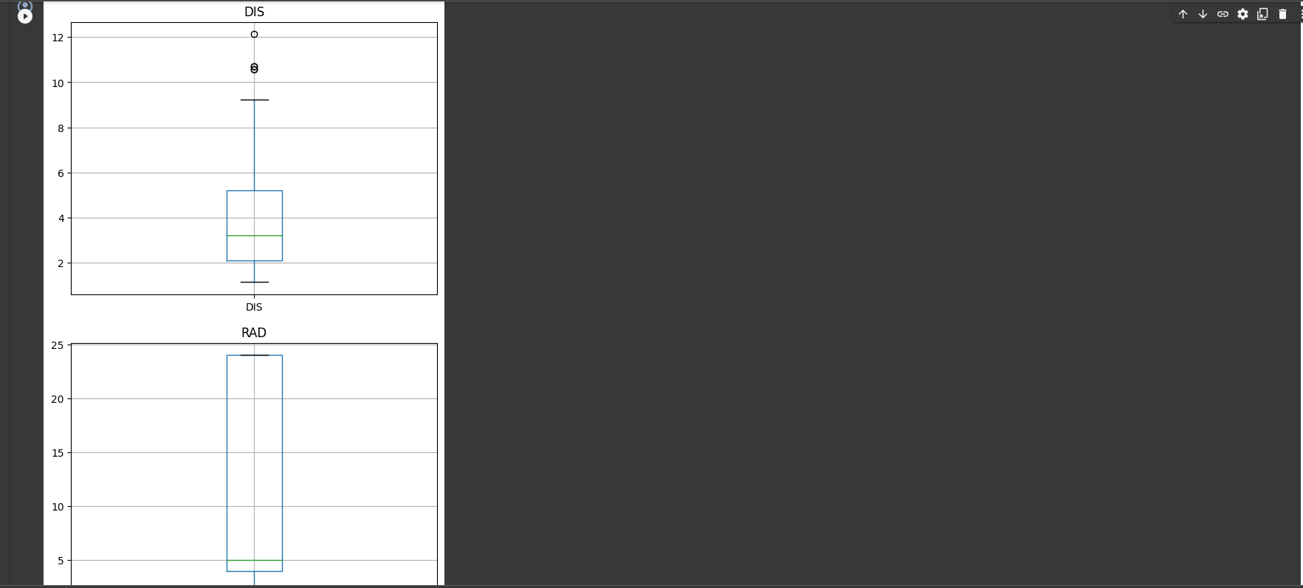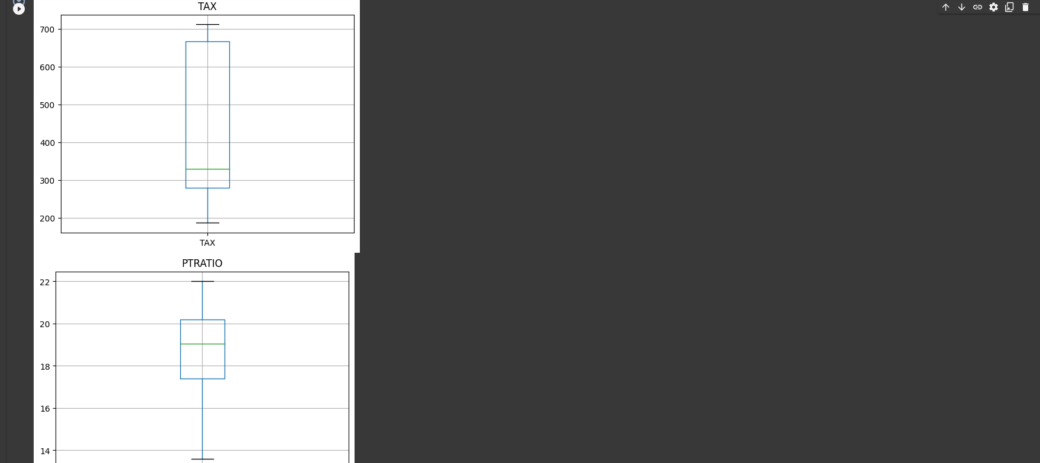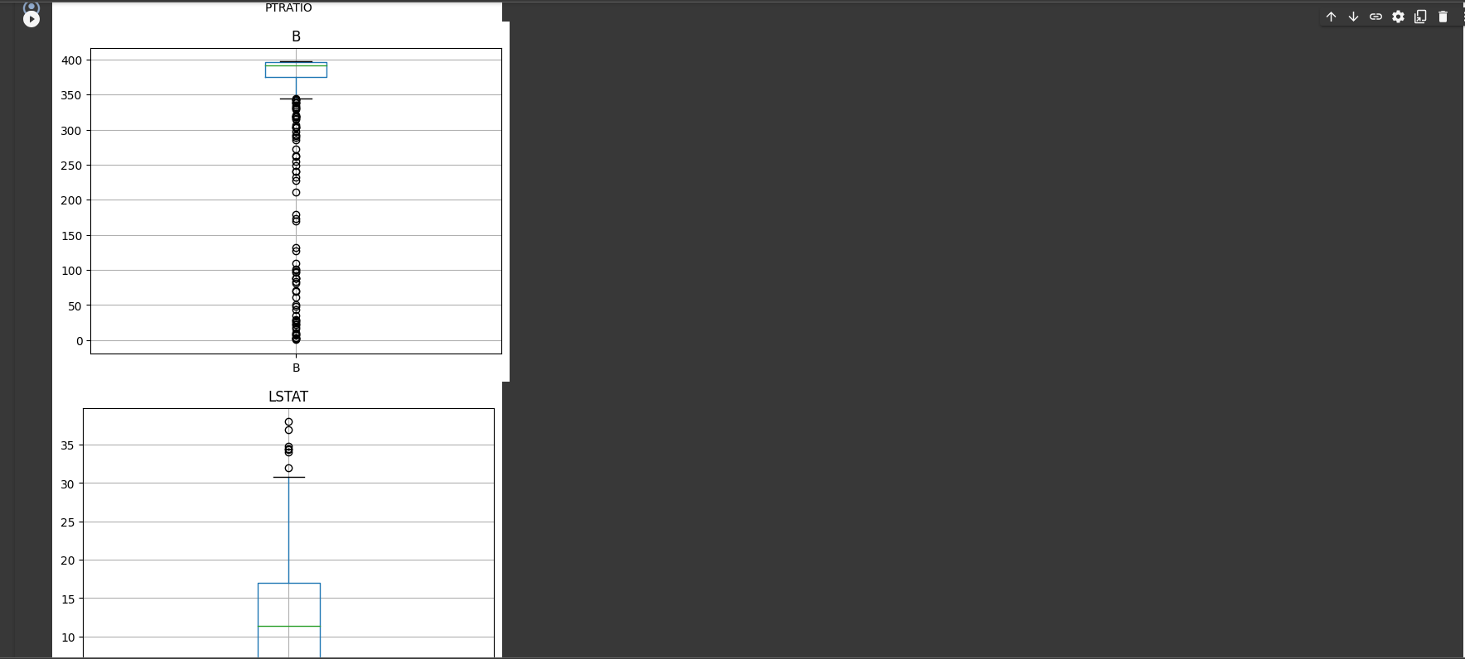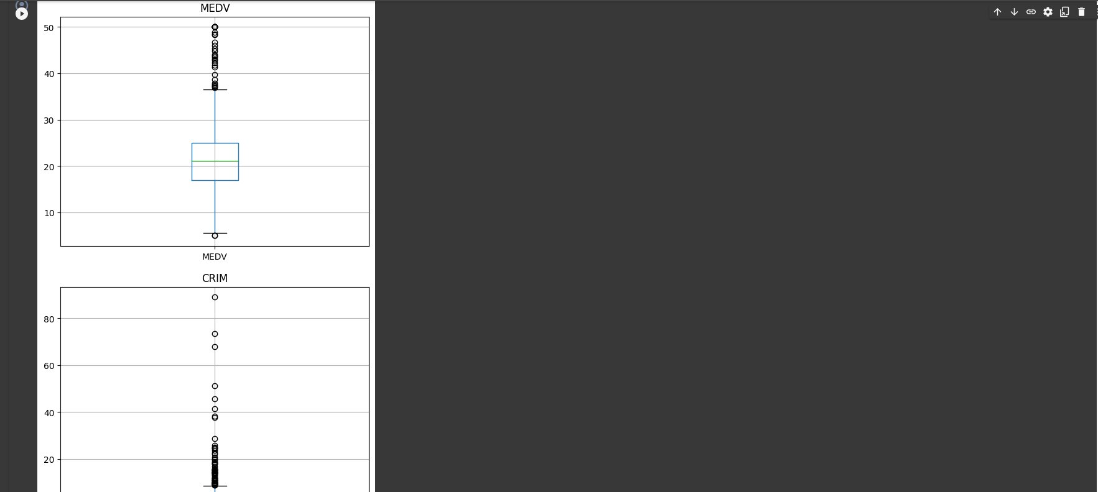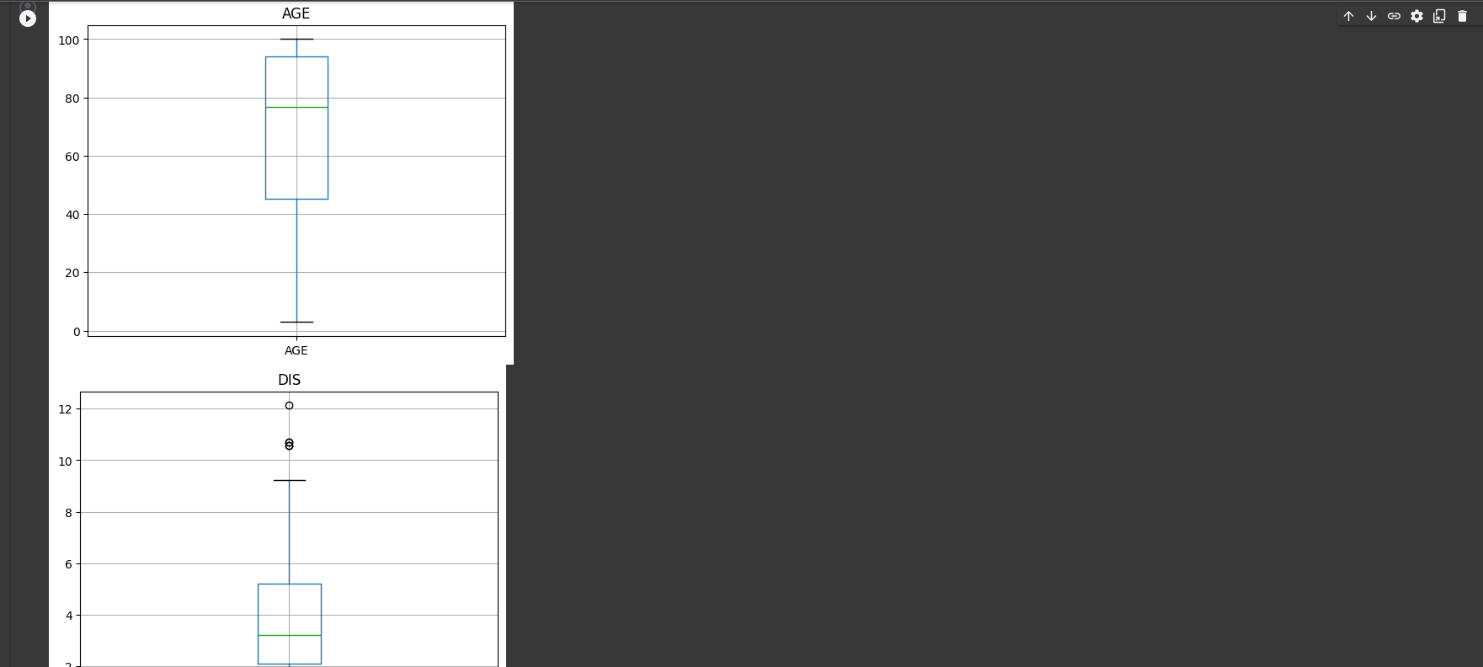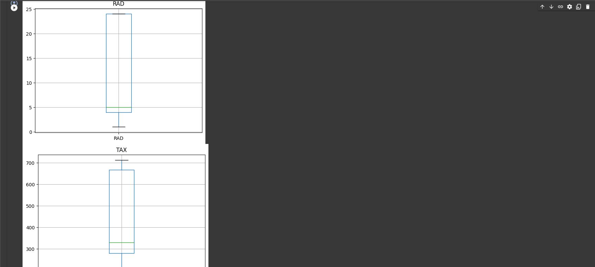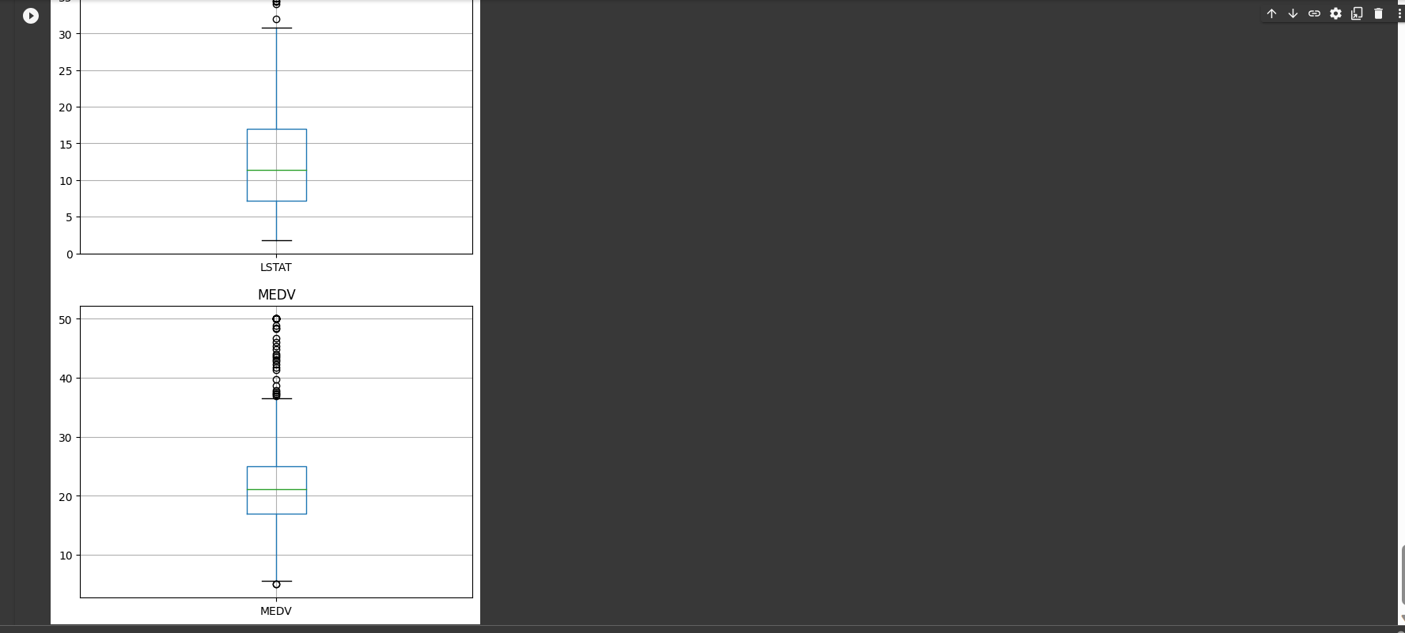

CODE:

# DURGAM NAGA DEERAJ REDDY(22BTRAD013)

import matplotlib.pyplot as plt

# Create box plots for each feature

for col in boston_housing.columns:

    boston_housing.boxplot(column=col)

    plt.title(col)

    plt.show()

import matplotlib.pyplot as plt

# Create box plots for each feature

for col in boston_housing.columns:

    boston_housing.boxplot(column=col)

    plt.title(col)

    plt.show()

# DURGAM NAGA DEERAJ REDDY(22BTRAD013)

# Calculate the z-score for each feature

for col in boston_housing.columns:

    z = (boston_housing[col] - boston_housing[col].mean()) / boston_housing[col].std()

    outliers = boston_housing[abs(z) > 3]

    print(f"Number of outliers for {col}: {len(outliers)}")

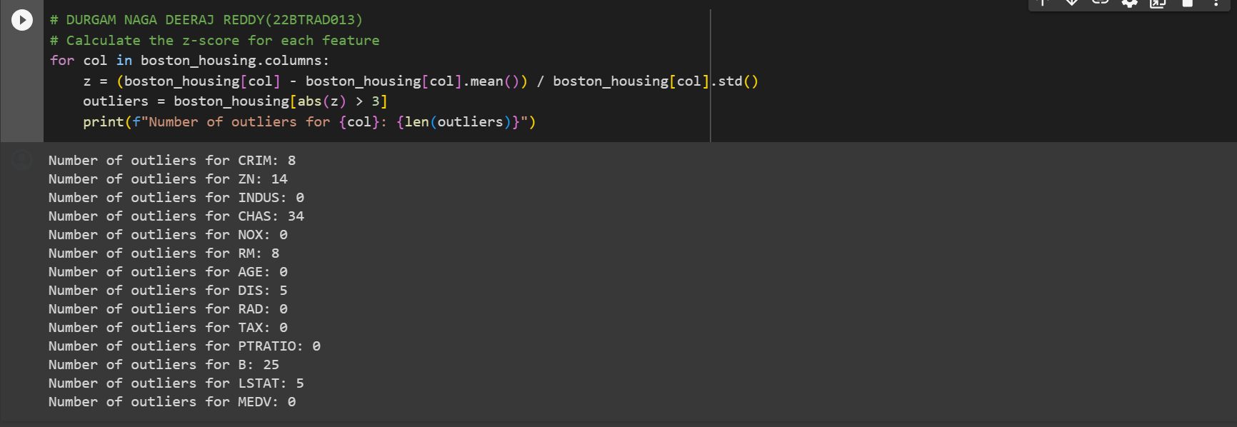

CODE:

# DURGAM NAGA DEERAJ REDDY(22BTRAD013)

# Calculate the z-score for each feature

for col in boston_housing.columns:

    z = (boston_housing[col] - boston_housing[col].mean()) / boston_housing[col].std()

    outliers = boston_housing[abs(z) > 3]

    print(f"Number of outliers for {col}: {len(outliers)}")

Q. Implement a strategy to handle outliers (e.g., removal and transformation)

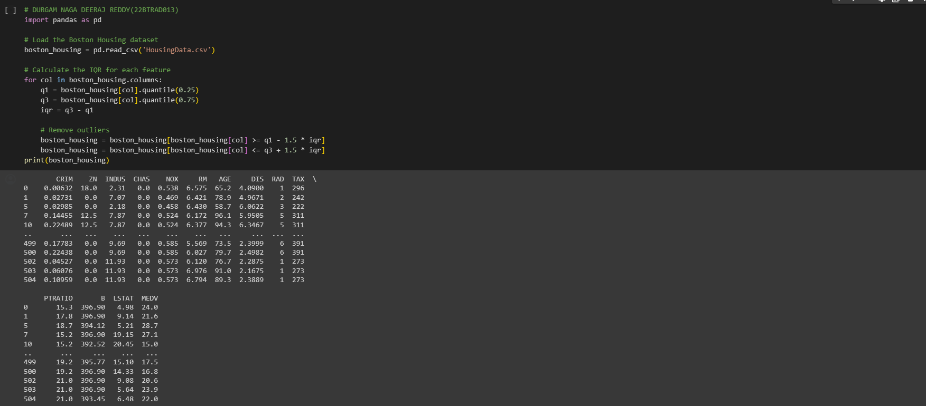

CODE:

# DURGAM NAGA DEERAJ REDDY(22BTRAD013)

import pandas as pd

# Load the Boston Housing dataset

boston_housing = pd.read_csv('HousingData.csv')

# Calculate the IQR for each feature

for col in boston_housing.columns:

    q1 = boston_housing[col].quantile(0.25)

    q3 = boston_housing[col].quantile(0.75)

    iqr = q3 - q1

    # Remove outliers

    boston_housing = boston_housing[boston_housing[col] >= q1 - 1.5 * iqr]

    boston_housing = boston_housing[boston_housing[col] <= q3 + 1.5 * iqr]

print(boston_housing)

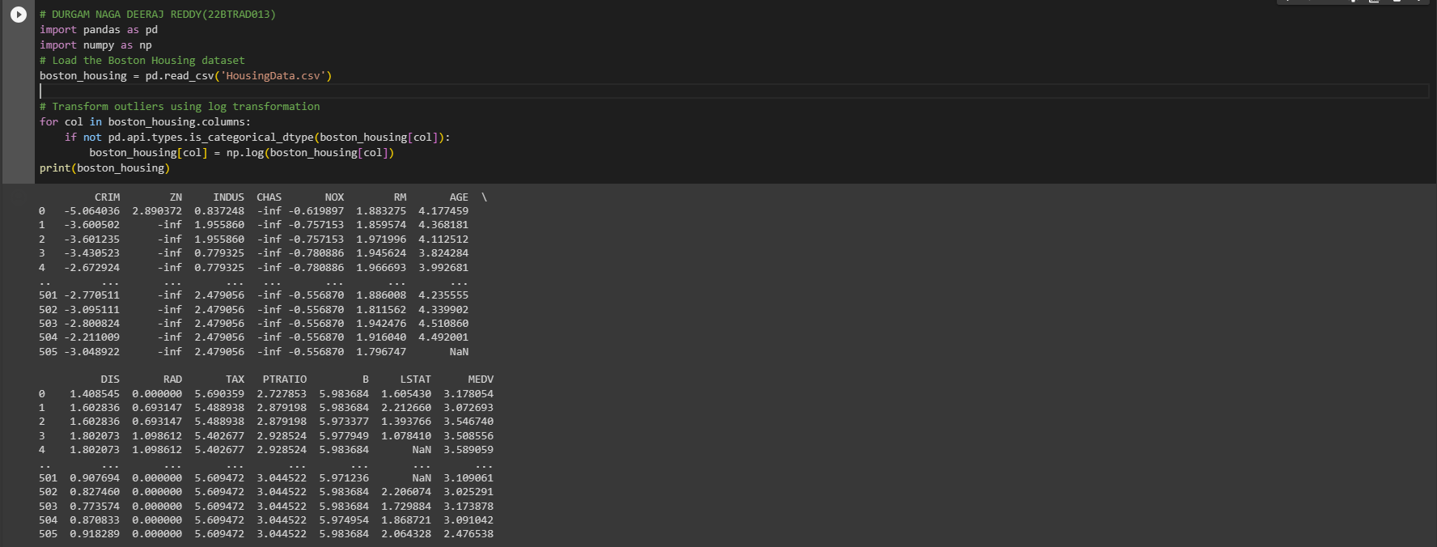

CODE:

# DURGAM NAGA DEERAJ REDDY(22BTRAD013)

import pandas as pd

import numpy as np

# Load the Boston Housing dataset

boston_housing = pd.read_csv('HousingData.csv')

# Transform outliers using log transformation

for col in boston_housing.columns:

    if not pd.api.types.is_categorical_dtype(boston_housing[col]):

        boston_housing[col] = np.log(boston_housing[col])

print(boston_housing)

GITHUB LINK:

https://github.com/DeeruReddy/Machine_learning